# Lab 8

Part 1

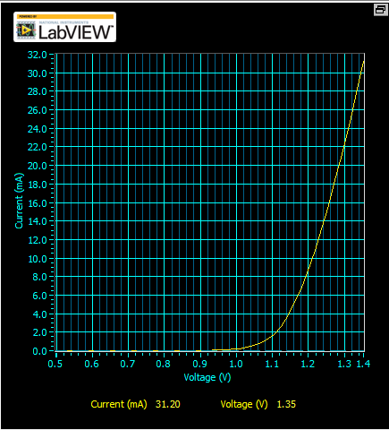



**1.255 v needed to produce 15Ma**

**Part 1 b**

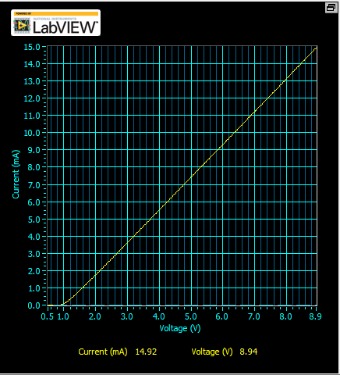

**510 * .015 +1.225 = 9V stop**

**510*.010+1.225 = 6V stop**

**510*.005+1.225 = 4V Stop**



**Part 2**

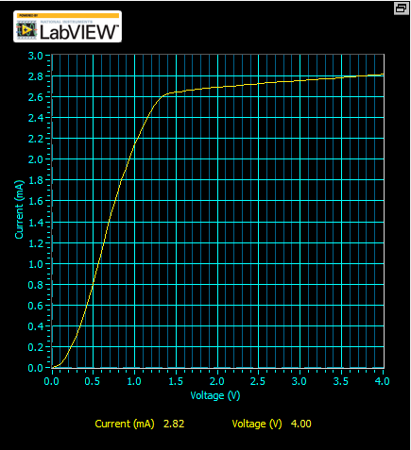



**Part 3**

**Graph1**

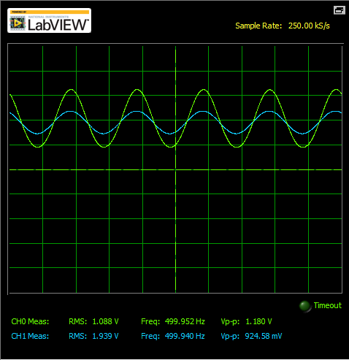

**Graph 2**

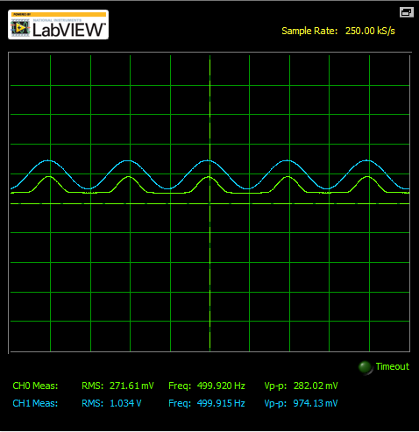

**Graph 3 – light blocked**

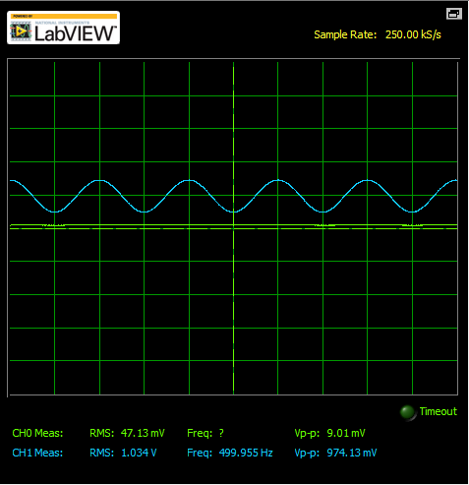

**Graph 4 – optocoupler**

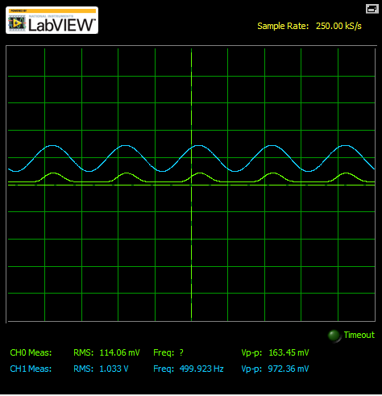

**Briefly explain what settings you adjusted, how you adjusted them to achieve an output waveform that does not show distortion, and why such adjustment worked.**

**Part 4**

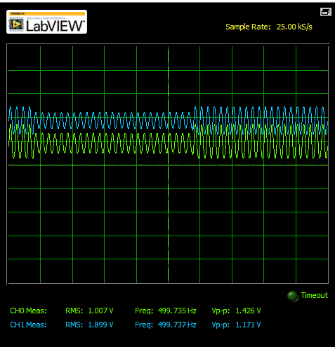

**Part 5**

